
Little Star Gifts Grand Opening Sale

Present this coupon for 15% off regular priced Anime merchandise (excluding DVDs & Manga)

This offer is valid from October18th, 2014
until October25th, 2014 only
No double discounts
1100 Milt Stegall Drive
www.winnipeganime.com
(204) 654-9577

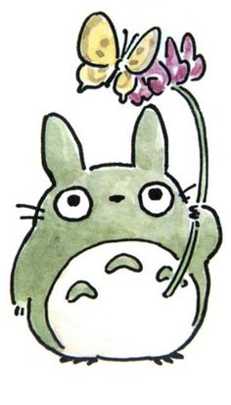
----------------------------------------------------------------------------------------------------------------------------------
Little Star Gifts Grand Opening Sale
1100 Milt Stegall Drive
www.winnipeganime.com
(204) 654-9577

Present this coupon for 15% off regular priced Anime merchandise (excluding DVDs & Manga)

This offer is valid from October18th, 2014
until Oct 25th, 2014 only
No double discounts

